Name: Abdul Rehman
Roll no: 067
Section: BSAI-3B
Lab task 2

Introduction:
In this lab I learned the concept of intelligent agents and the PEAS framework. An agent observes its environment through sensors and acts on it through actuators. A rational agent is one that chooses the best action according to the given performance measure and the information available to it. ECO, COOL, WARM and IDLE are only simulated mode labels; no real hardware is controlled.

PEAS Specification: Delivery Robot
PEAS | Description
Performance | Safe delivery, correct destination, on-time arrival, no collisions
Environment | Campus roads and corridors, students, obstacles, weather
Actuators | Wheels, motors, steering, brake, horn/alert
Sensors | Camera, GPS, obstacle/proximity sensor, speed sensor
Trade-off: in trying to deliver quickly, the robot must not travel at an unsafe speed. Safety must therefore be ranked above speed in the performance measure.
Assumption: the robot already has the delivery request and the map; the simulation uses only these inputs.

PEAS Specification: LLM-based Student Support Agent
PEAS | Description
Performance | Correct and supported answers, fast reply, polite tone, no made-up information
Environment | University, students, LMS, course documents
Actuators | Text reply, notifications, escalation to human staff
Sensors | Student questions, uploaded documents, LMS records
Trade-off: if the agent only tries to reply faster, it may give unsupported (incorrect) answers. Correctness and source support should therefore matter more than speed.
Assumption: the agent's tools are reading the LMS, searching course documents, and escalating issues to human staff. It cannot edit grades or private records.

Environment Classification:
System | Observability | Environment type | Justification
Delivery Robot | Partially observable | Stochastic | Hidden: the pedestrian's next move. Uncertain: wheel slip or sensor noise can change the result of an action.
Student support agent | Partially observable | Stochastic | Hidden: the student's real confusion or a wrong uploaded file. Uncertain: the LLM's reply can differ slightly each time.
Note: a simplified simulator (like our classroom script) is deterministic, but a real environment is partially observable and stochastic (for example sensor faults or outside weather). This classification is based on the stated assumptions.

Python Program: Reflex Agent (lab2_percepts.py)
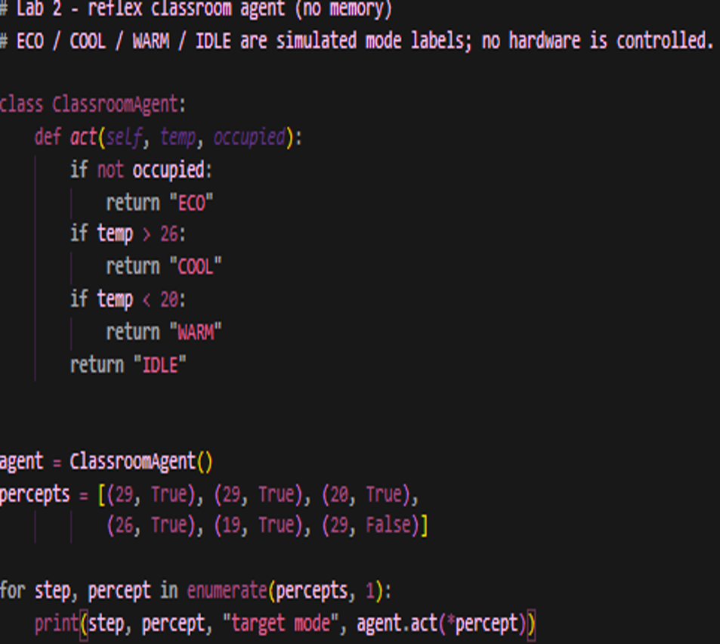

Expected output: COOL, COOL, IDLE, IDLE, WARM, ECO
Actual output:
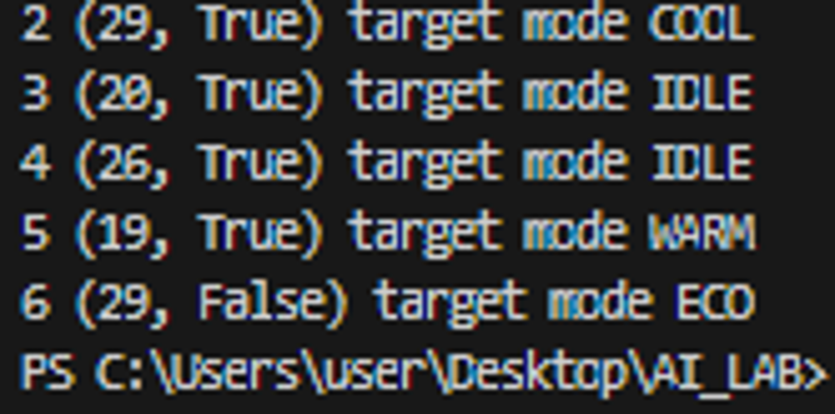
The reflex agent returns COOL twice because it has no memory that the previous command was already COOL.

Python Program: Stateful Agent (lab2_model.py)
The agent now remembers previous_mode and returns (previous, target, send_command). The temperature thresholds and the occupancy priority are the same as before.
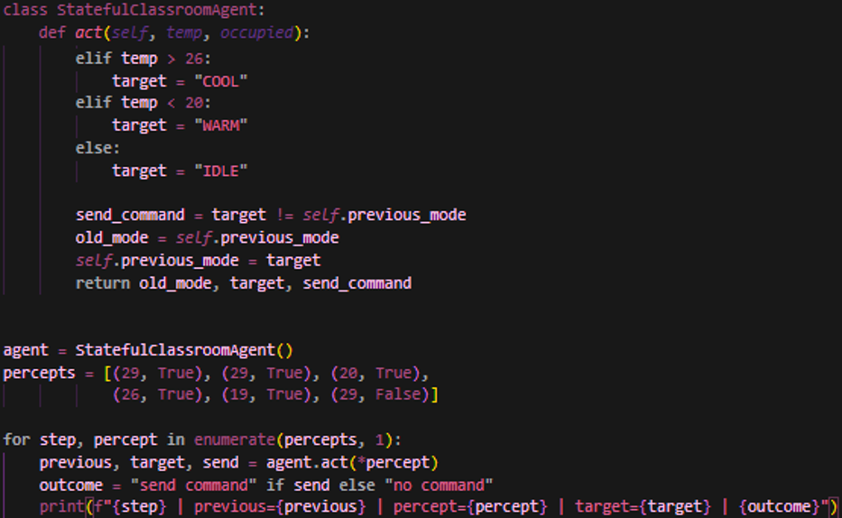

Actual output:
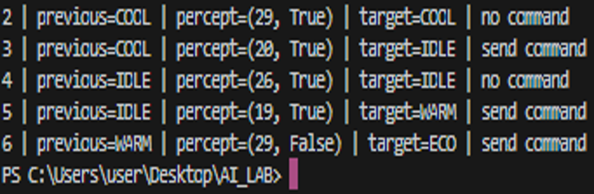

Mode-transition trace:
Step | Previous mode | Percept | Target | Command
1 | None | (29, True) | COOL | send command
2 | COOL | (29, True) | COOL | no command (repeat)
3 | COOL | (20, True) | IDLE | send command (boundary 20)
4 | IDLE | (26, True) | IDLE | no command (boundary 26)
5 | IDLE | (19, True) | WARM | send command (transition)
6 | WARM | (29, False) | ECO | send command (empty room)

Reflex vs Stateful Comparison
Point | Reflex agent | Stateful agent
Memory | None | Remembers the previous mode
Repeated percept | Sends the same command again | Does not send the command again
Return value | Returns only the target mode | Returns previous, target and send flag
Learning | No | No (only remembers the last mode; does not learn from data)

Edge Case / Failure Analysis
Input: noisy temperature sequence 25.9, 26.1, 25.9, 26.1, 25.9, 26.1 (occupied room).
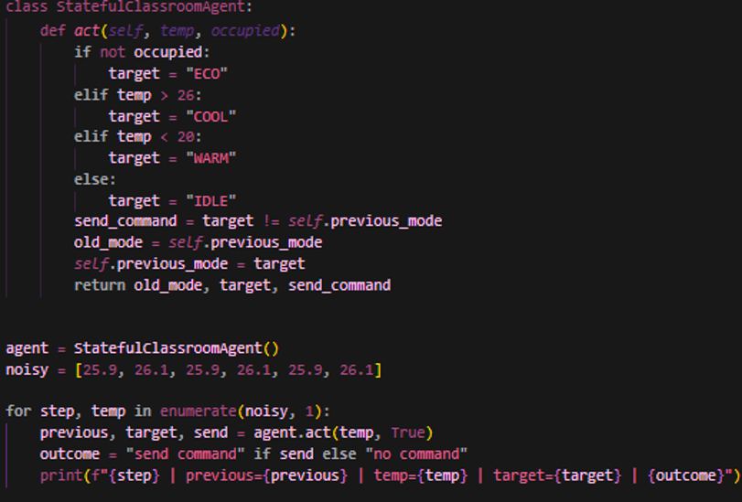

Observed behavior: the target keeps switching back and forth between IDLE and COOL, and a command is sent at every step.
Likely cause: remembering only the previous mode does not create hysteresis. The threshold of 26 is so strict that even a small amount of noise changes the mode.
Proposed improvement: use hysteresis, for example start COOL when temp is above 26 and keep it running until temp falls below 25.

Classical vs LLM-based Agent
A classical agent works with fixed rules and an explicit state (like our classroom agent), so its behavior is predictable and traceable. An LLM-based agent understands natural language and uses tools, but its output is probabilistic and can sometimes be wrong (unsupported), so it needs source checking and human escalation.

Limitations
The classroom script is a simple, deterministic simulator with no model of sensor faults or comfort. The stateful agent also does not provide hysteresis. PEAS only describes the task environment; it does not implement a rational policy by itself.

Reflection
What did you learn today? I learned the difference between an agent, a percept, an action and PEAS, and that remembering state and learning from data are two different things.
How will you apply this? When designing a real system, I will first write the PEAS description and include safety in the performance measure.
What failed or surprised you? It surprised me that even the stateful agent keeps changing mode on noisy values.
What would you do differently? I would build a version with hysteresis and test it.

Responsible Practice
The performance measure should include safety and constraints, not just speed or task completion. All values are synthetic and no hardware is controlled.

